Ecomap Teaching Pack
Castleport Test Prep · Edition September 2026 · Free teaching reuse with credit
What is inside: a 45-minute lesson, six fictional case cards, a worked answer key for all 36 connections, six check-your-understanding questions, and a 10-point feedback rubric. Use it with the blank template and key from castleporttestprep.com/research/ecomap-template/.
Every case in this pack is made up. None is a real person, client, or survey response.

1. A 45-minute lesson
Minutes | What happens | Materials
0–5 | Hand out the key. Show that published guides draw the stressful line in different ways, so every map needs its key. | Key card
5–15 | Everyone sketches their own ecomap. Hartman (1978, p. 468) suggested learning the tool on yourself first. Keep it private; anyone may use a made-up person instead. | Blank template
15–30 | Pairs pick a case card (1–5). Fill in the worksheet first, then draw the map. | Case card, worksheet, template
30–40 | Swap maps. Score each other with the rubric, using the answer key. | Answer key, rubric
40–45 | Debrief: What did the map show that a list would not? Which line did you argue about, and why? | None
Timing is a planning guide, not a tested completion time.

2. Student case cards
Give students the story only. Ask them to fill in the worksheet, then draw the map with the key.

Example 1: The Rivera household · Child welfare (in-home services)
Dana, 34, lives with her kids Leo, 9, and Mia, 6. A child welfare caseworker has started visiting. Dana's mom, Rosa, watches the kids after school, and Dana cooks Rosa Sunday dinner. Leo says he likes his teacher. The school's attendance office keeps calling Dana about Mia's missed days, and Dana says the calls stress her out. The rent just went up and repairs are late. Dana has met the caseworker twice but hasn't said how it's going. She needs an after-school program for the two days Rosa works, and hasn't found one yet.
Fictional teaching case.

Example 2: Jaylen, 12 · School social work
Jaylen is in seventh grade. His older sister Keisha helps with homework most nights. He says his basketball coach, Reyes, 'gets me', and he shows up early to help set up. His dad lives in another state; they text sometimes. Some kids at his lunch table tease him. He plays online games with friends most nights and calls them 'fun but not real friends'. He met the school counselor once at orientation.
Fictional teaching case.

Example 3: Ruth, 81 · Aging, home health and hospital discharge
Ruth came home last week after a hospital stay. Her neighbor Carl picks up her groceries, and she reads with his grandkids after school. Her daughter Anne lives 900 miles away and calls every Sunday; Ruth calls her 'my rock'. The pharmacy has made two billing mix-ups this month, and Ruth says it 'wears me out'. She went to the senior center twice last year. A home health nurse visits twice a week, and Ruth says the nurse is kind. Ruth can't drive yet, and no one has set up rides to her follow-up visits.
Fictional teaching case.

Example 4: Priya, 29 · Substance use recovery counseling
Priya is in early recovery. She goes to a peer support group three times a week, where she listens and shares her own story. Her sister Meera lets her stay with her and checks in every day. Her old friend group still invites her to parties, and Priya says saying no is hard. Her job gives her a steady paycheck, but her manager changes her shifts at the last minute. She has weekly counseling sessions but hasn't said how they feel. She and her mom haven't talked in a year; Priya says she misses her.
Fictional teaching case.

Example 5: The Haddad household · Refugee resettlement
Omar and Lina Haddad arrived three months ago with their kids Sami, 10, and Nour, 7. Their resettlement caseworker helped them find an apartment and sort out paperwork. Lina goes to English class four mornings a week and has made two friends there. The family video-calls relatives abroad every weekend and sends money home each month. Omar works night shifts at a warehouse; the pay covers rent, but he rarely sees the kids awake. At school, Sami and Nour are learning English fast. The school sends notes home only in English, which Omar and Lina can't yet read.
Fictional teaching case.

Example 6: Alex, 24 (a student's own ecomap) · Social work education: drawing your own map first
Alex is a first-year MSW student drawing a personal ecomap for class. Alex's partner, Sam, shares rent and cooking, and Alex calls Sam 'my person'. At Alex's field placement, weekly supervision is useful, but the caseload feels heavy. A coffee-shop job pays well and the manager is flexible about class times. A study group meets before exams to share notes and quiz each other. Monthly calls with Alex's parents keep turning into arguments about student loans. Alex has the campus counseling center's number but hasn't gone.
Fictional teaching case.

3. Answer key: all 36 connections
Each row gives the fact from the story, the mark it gets, why, and what not to read into it. These are worked teaching choices, not the only valid drawings; a different mark needs a clear reason tied to the case and its key.

Example 1: The Rivera household
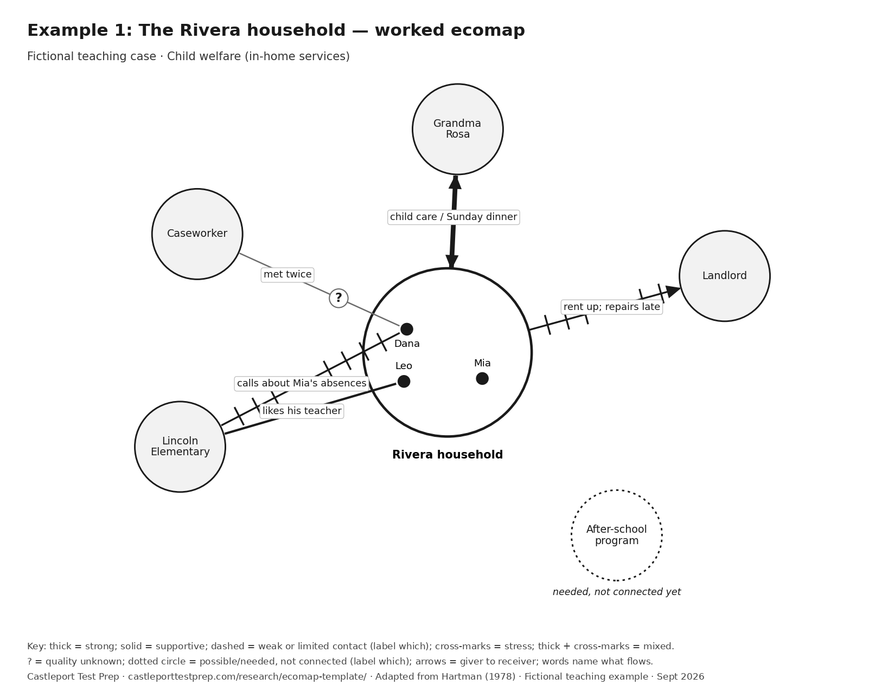

Example 1: connection key
ID | Connection | What the story says | Mark and arrow | Why | Don't read in
E1-1 | Grandma Rosa — Whole household | Rosa watches the kids after school; Dana cooks her Sunday dinner. | Thick solid line (strong). Arrow: Both ways: child care to the family; Sunday dinner to Rosa. Words: child care / Sunday dinner | Regular after-school care is dependable practical help, and help goes both ways. This is a teaching interpretation of the stated routine, not an extra statement by Dana. | Two arrowheads do not mean the help is equal. They mean help flows both ways.
E1-2 | Lincoln Elementary (Leo's class) — Leo | Leo says he likes his teacher. | Solid line (supportive). Arrow: None stated. Words: likes his teacher | A positive connection, attached to Leo because it is his. | Don't draw one line from the school to the whole family. Leo's tie and Dana's tie are different.
E1-3 | Lincoln Elementary (attendance office) — Dana | The attendance office keeps calling Dana about Mia's missed days; Dana says the calls stress her. | Line with cross-marks (stressful). Arrow: None stated. Words: calls about Mia's absences | Dana names this connection as stressful, so it gets cross-marks, attached to Dana. | Don't label the school 'bad'. The same school has a good tie with Leo.
E1-4 | Landlord — Whole household | Rent went up and repairs are late. | Line with cross-marks (stressful). Arrow: Household to landlord: rent. Words: rent up; repairs late | The story names two strains, so the line gets cross-marks. The arrow shows rent going out. | Don't assume a legal or safety problem. The story only says rent rose and repairs are late.
E1-5 | Caseworker — Dana | They have met twice. Dana hasn't said how it's going. | Thin line with ? (quality not known yet). Arrow: None stated. Words: met twice | The connection exists, but no one has described its quality yet. | Unknown is not the same as weak. Don't use a dashed line here.
E1-6 | After-school program — Whole household | Dana needs care for the two days Rosa works and hasn't found a program yet. | No line; dotted circle (needed, not connected yet). Arrow: None. Words: needed, not connected yet | A dotted circle with no line shows a resource the family needs but doesn't have. | Don't draw a weak line. There is no connection yet.

Example 2: Jaylen, 12
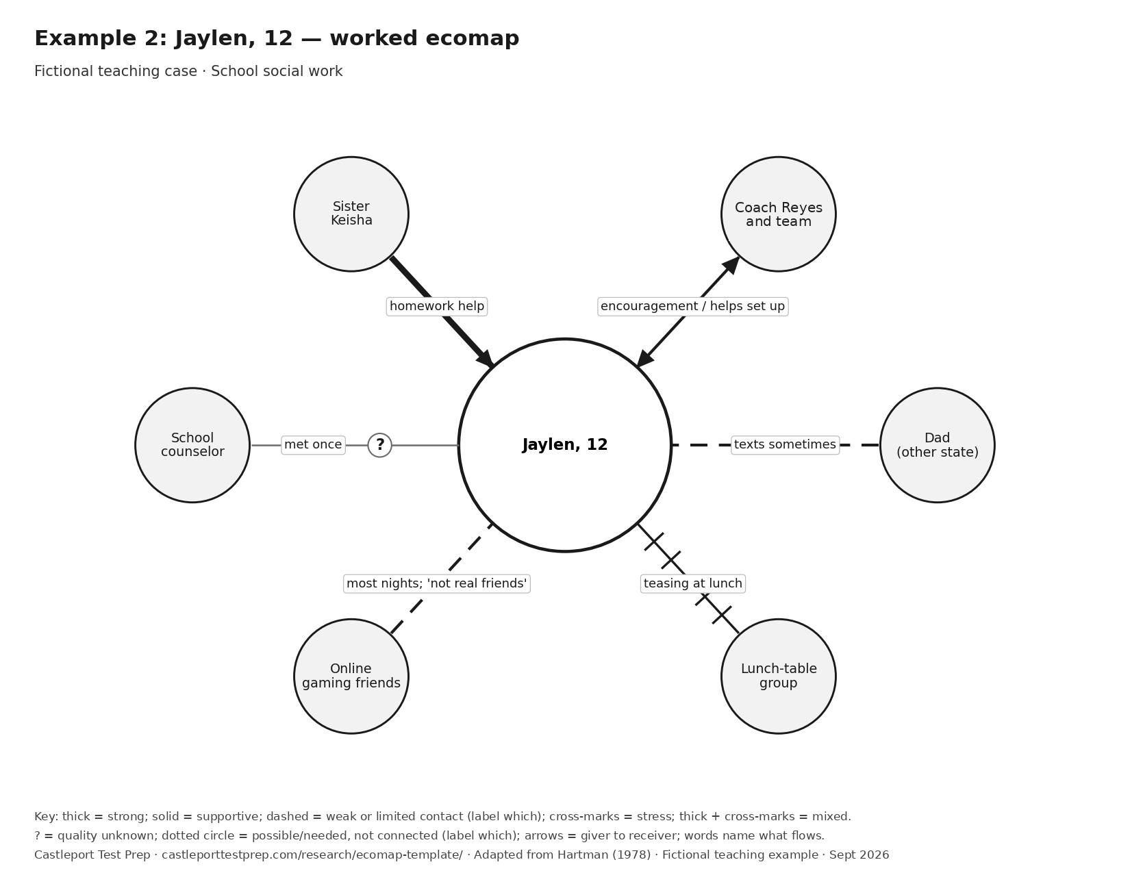

Example 2: connection key
ID | Connection | What the story says | Mark and arrow | Why | Don't read in
E2-1 | Sister Keisha — Jaylen | Keisha helps with homework most nights. | Thick solid line (strong). Arrow: Keisha to Jaylen: homework help. Words: homework help | Help most nights is dependable practical support. The arrow points to Jaylen because he receives it. | Don't add an arrow back to Keisha unless the story says Jaylen gives something to her.
E2-2 | Coach Reyes and team — Jaylen | Jaylen says Coach 'gets me' and he comes early to help set up. | Solid line (supportive). Arrow: Both ways: encouragement to Jaylen; set-up help to the team. Words: encouragement / helps set up | A good connection with something flowing each way. | Giving time is not a burden unless the story says it is.
E2-3 | Dad — Jaylen | Dad lives in another state. They text sometimes. | Dashed line (limited contact; quality not rated). Arrow: None stated. Words: texts sometimes | The dashed line describes occasional contact here, not emotional closeness. The words keep that distinction clear. | Living far away and texting sometimes do not establish a weak emotional bond or conflict. Nothing in the story says they argue.
E2-4 | Lunch-table group — Jaylen | Some kids at his lunch table tease him. | Line with cross-marks (stressful). Arrow: None stated. Words: teasing at lunch | The teasing is the stated strain shown by the cross-marks; the story does not report how Jaylen rates the whole relationship. | Record the teasing without adding facts about its frequency, threats or Jaylen's feelings.
E2-5 | Online gaming friends — Jaylen | Plays most nights; calls them 'fun but not real friends'. | Dashed line (weak or distant). Arrow: None stated. Words: most nights; 'not real friends' | Frequent contact, but Jaylen himself rates the tie as light. His words decide the line. | Frequent does not automatically mean strong.
E2-6 | School counselor — Jaylen | Met once at orientation. | Thin line with ? (quality not known yet). Arrow: None stated. Words: met once | There is a connection, but no one knows yet what it's like. | Don't guess. Ask Jaylen about it.

Example 3: Ruth, 81
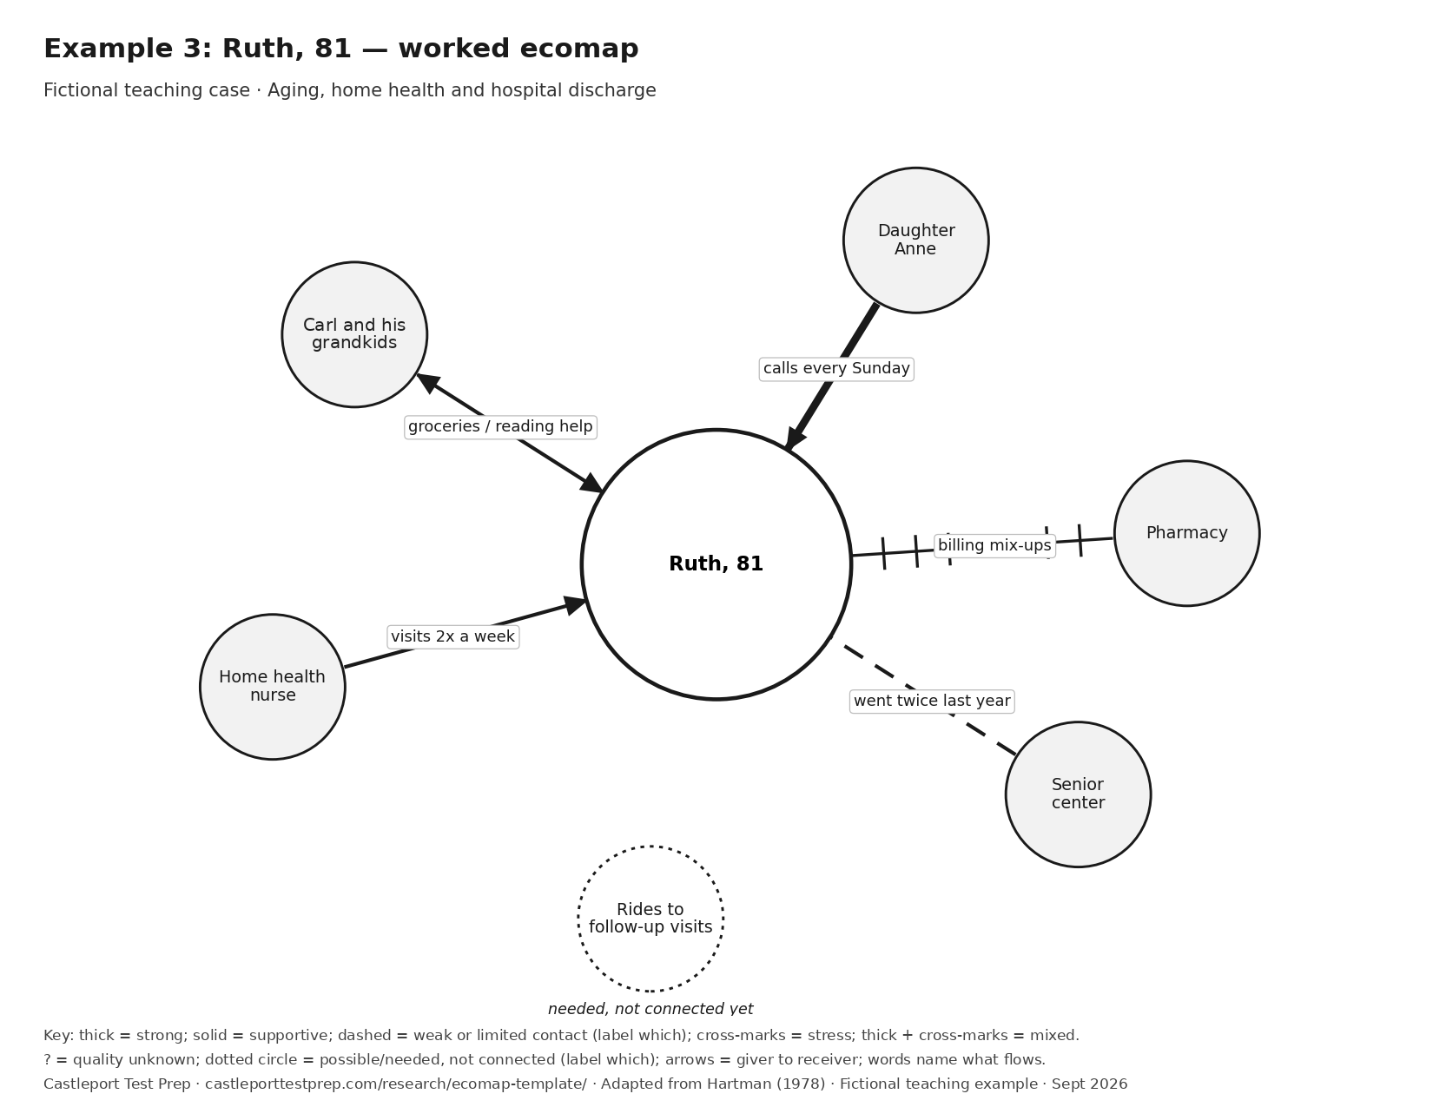

Example 3: connection key
ID | Connection | What the story says | Mark and arrow | Why | Don't read in
E3-1 | Carl and his grandkids — Ruth | Carl picks up groceries; Ruth reads with his grandkids. | Solid line (supportive). Arrow: Both ways: groceries to Ruth; reading help to Carl's grandkids. Words: groceries / reading help | A good tie where Ruth gives as well as gets. | Older adults are not only receivers. Show what Ruth gives.
E3-2 | Daughter Anne — Ruth | Anne lives 900 miles away, calls every Sunday; Ruth calls her 'my rock'. | Thick solid line (strong). Arrow: Anne to Ruth: weekly calls. Words: calls every Sunday | Ruth's own words mark this as a strong tie. She has not ranked it against her other connections. | Far away does not mean weak. Distance is not what the line measures.
E3-3 | Pharmacy — Ruth | Two billing mix-ups this month; Ruth says it 'wears me out'. | Line with cross-marks (stressful). Arrow: None stated. Words: billing mix-ups | Ruth describes the connection as draining. | Don't assume she can't get her medicine. The story is about billing.
E3-4 | Senior center — Ruth | Went twice last year. | Dashed line (limited contact; quality not rated). Arrow: None stated. Words: went twice last year | A light, occasional contact pattern. The story does not rate how helpful or close the connection feels. | Don't assume she dislikes it. Ask.
E3-5 | Home health nurse — Ruth | Visits twice a week; Ruth says the nurse is kind. | Solid line (supportive). Arrow: Nurse to Ruth: visits. Words: visits 2x a week | A supportive service, with care flowing to Ruth. | Don't make it strong just because it's frequent. Ruth said kind, not close.
E3-6 | Rides to follow-up visits — Ruth | Ruth can't drive yet; no rides are set up. | No line; dotted circle (needed, not connected yet). Arrow: None. Words: needed, not connected yet | A gap in help is its own circle, not a mark on another line. | The missing ride doesn't change how good the nurse or Carl is. Keep the gap separate.

Example 4: Priya, 29
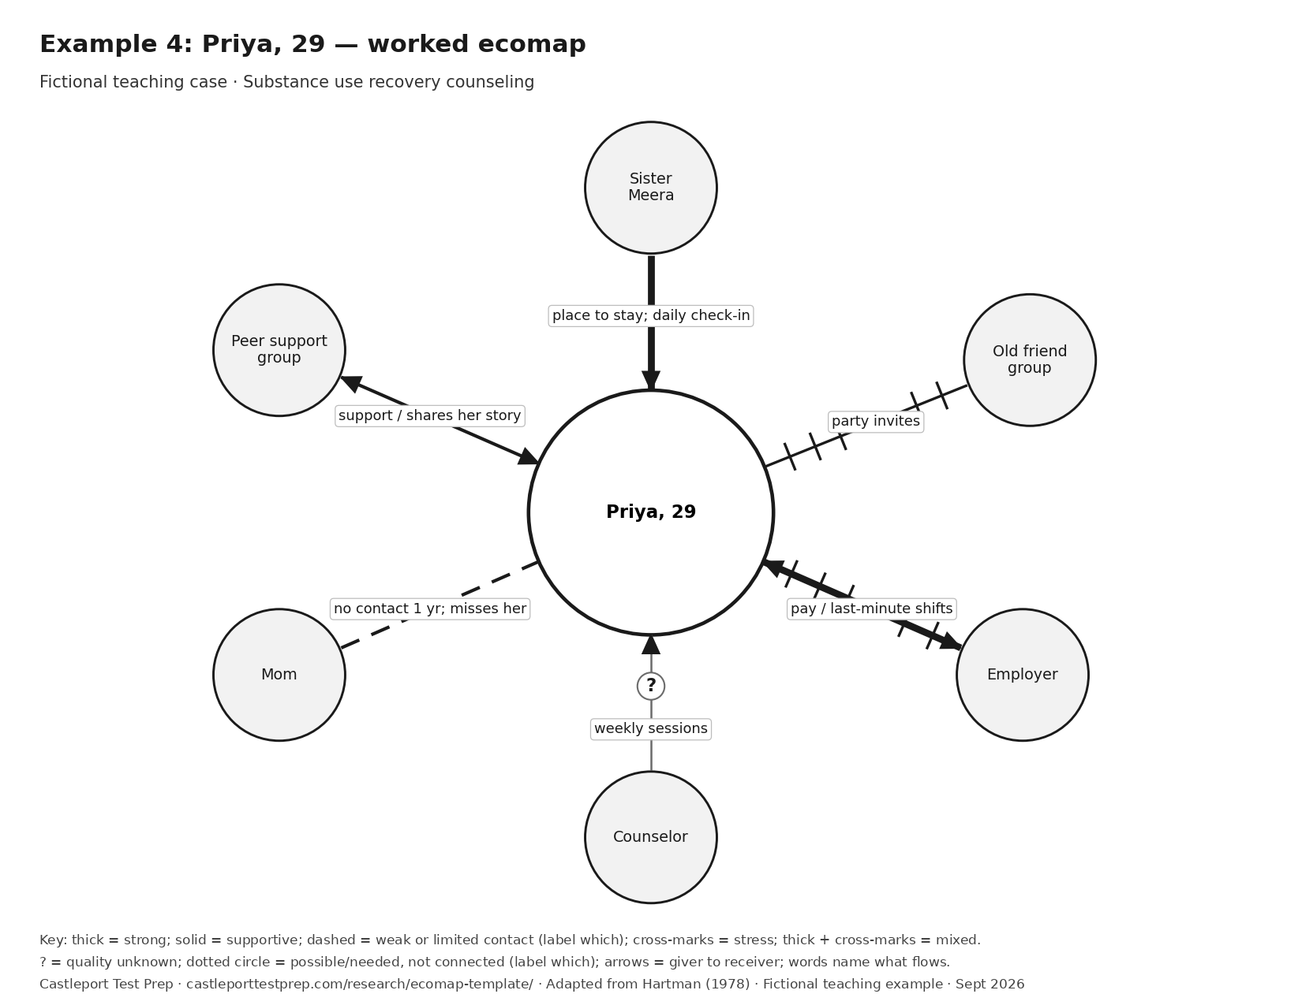

Example 4: connection key
ID | Connection | What the story says | Mark and arrow | Why | Don't read in
E4-1 | Peer support group — Priya | Goes three times a week; listens and shares her story. | Solid line (supportive). Arrow: Both ways: support to Priya; her story to the group. Words: support / shares her story | A supportive tie where Priya also gives. | Don't assume the group is her strongest tie. She didn't rank it.
E4-2 | Sister Meera — Priya | Lets Priya stay with her; checks in every day. | Thick solid line (strong). Arrow: Meera to Priya: a place to stay and daily check-ins. Words: place to stay; daily check-in | Housing plus daily contact is strong, dependable help. | Don't add stress to this line. The story doesn't mention any.
E4-3 | Old friend group — Priya | They still invite her to parties; saying no is hard. | Line with cross-marks (stressful). Arrow: None stated. Words: party invites | Priya names the pull of this group as hard. | Write what she said. Don't label the friends on the map.
E4-4 | Employer — Priya | Steady paycheck; manager changes shifts at the last minute. | Thick solid line with cross-marks (helps and stresses). Arrow: Both ways: pay to Priya; work to the employer. Words: pay / last-minute shifts | The job helps and stresses at once, so both marks stay. | Don't erase the help because of the stress, or the stress because of the help.
E4-5 | Counselor — Priya | Weekly sessions; Priya hasn't said how they feel. | Thin line with ? (quality not known yet). Arrow: Counselor to Priya: weekly sessions. Words: weekly sessions | You can know which way help flows before you know how good it feels. | Unknown quality is not weak quality.
E4-6 | Mom — Priya | No contact in a year; Priya says she misses her. | Dashed line (no recent contact; quality not rated). Arrow: None stated. Words: no contact 1 yr; misses her | There has been no contact for a year. The dashed line records that contact gap, not a judgment about their bond; the words record that Priya misses her. | No contact is not the same as conflict. The story names no fight.

Example 5: The Haddad household
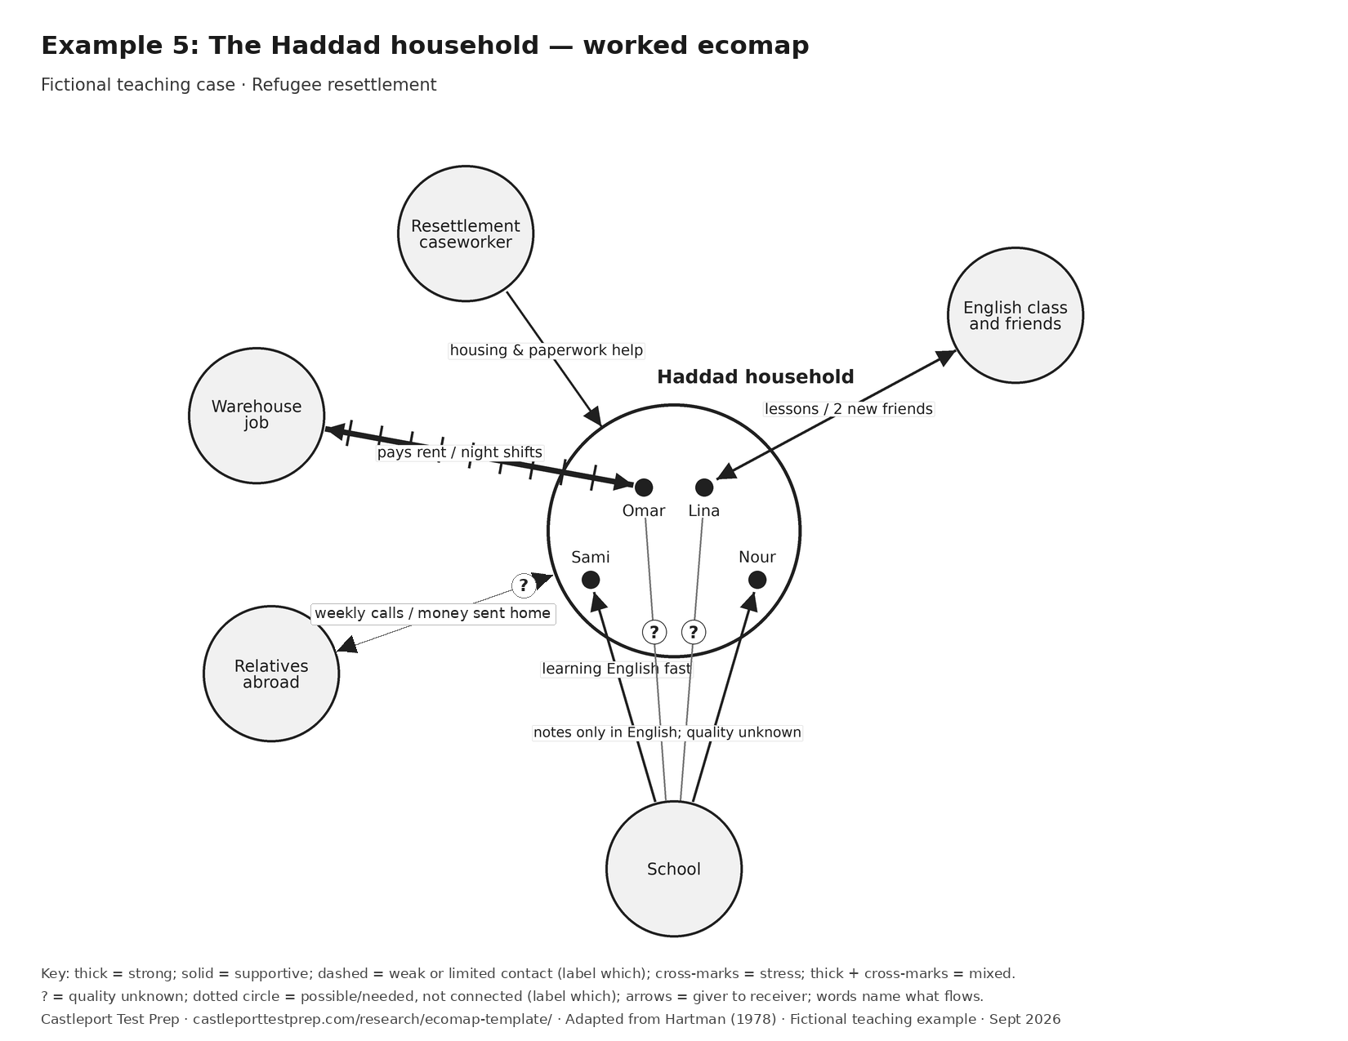

Example 5: connection key
ID | Connection | What the story says | Mark and arrow | Why | Don't read in
E5-1 | Resettlement caseworker — Whole household | Helped find the apartment and sort out paperwork. | Solid line (supportive). Arrow: Caseworker to family: housing and paperwork help. Words: housing & paperwork help | A supportive service, with help flowing in. | Don't assume the tie is strong. The family didn't describe it that way.
E5-2 | English class and friends — Lina | Lina goes four mornings a week and made two friends. | Solid line (supportive). Arrow: Both ways: lessons to Lina; friendship with classmates. Words: lessons / 2 new friends | A good tie, and it's Lina's, so it attaches to her. | Don't attach it to the whole family.
E5-3 | Relatives abroad — Whole household | Video calls every weekend; the family sends money home each month. | Thin line with ? (quality not known yet). Arrow: Both ways: calls both ways; money from family to relatives. Words: weekly calls / money sent home | The calls and money transfers are stated, but no one describes how the relationship feels. Show the flows and leave the quality unknown. | Money going out is not automatically a burden. The story doesn't say it is.
E5-4 | Warehouse job — Omar | Night shifts; pay covers rent; he rarely sees the kids awake. | Thick solid line with cross-marks (helps and stresses). Arrow: Both ways: pay to Omar; work to the employer. Words: pays rent / night shifts | The job helps and strains at once, so both marks stay, attached to Omar. | Don't attach the job to Lina or the kids.
E5-5 | School (kids) — Sami and Nour | Sami and Nour are learning English fast. | Solid line (supportive). Arrow: School to kids: lessons. Words: learning English fast | A supportive tie for each child. | The kids' tie and the parents' tie are different. Keep both.
E5-6 | School (parents) — Omar and Lina | Notes come home only in English, which the parents can't yet read. | Thin line with ? (quality not known yet). Arrow: None stated. Words: notes only in English | The notes create a language-access barrier. That alone does not establish the quality of the parents' relationship with the school. | Do not turn a language-access barrier into a weak or conflicted relationship. Keep the barrier in the words on the line.

Example 6: Alex, 24 (a student's own ecomap)
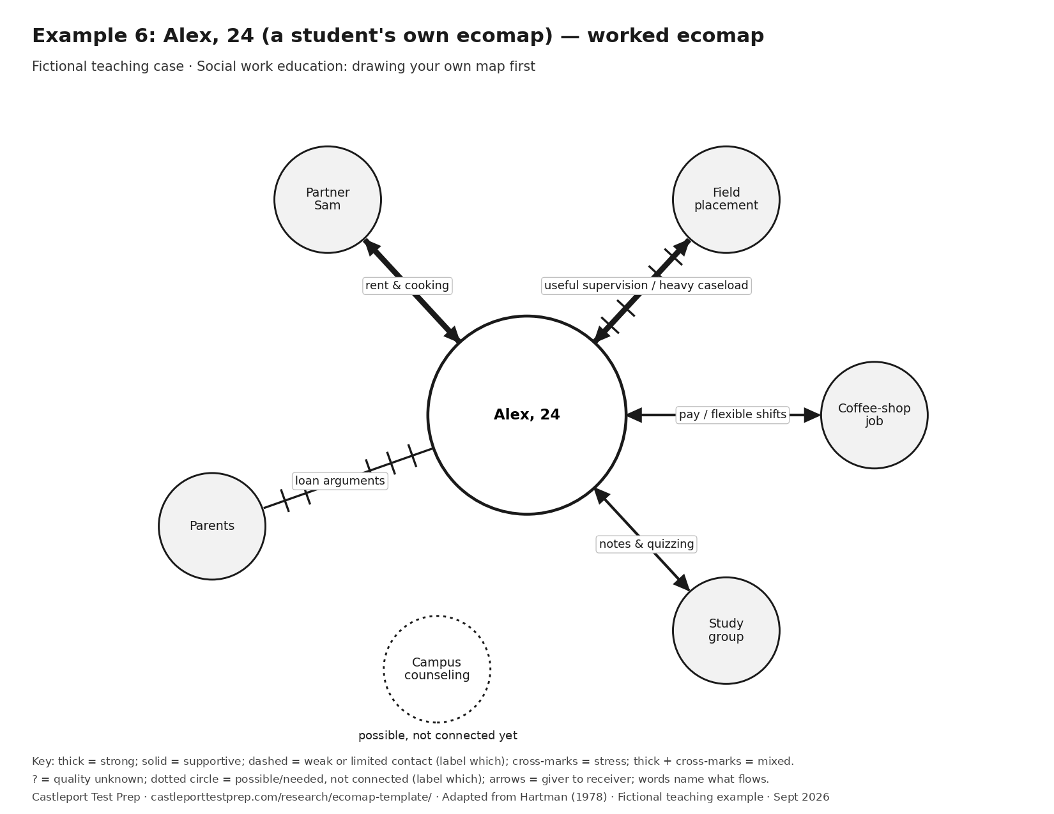

Example 6: connection key
ID | Connection | What the story says | Mark and arrow | Why | Don't read in
E6-1 | Partner Sam — Alex | Shares rent and cooking; Alex calls Sam 'my person'. | Thick solid line (strong). Arrow: Both ways: rent and cooking shared. Words: rent & cooking | Alex's own words mark this as a strong tie, not necessarily the strongest one. | Two arrowheads don't mean perfectly equal.
E6-2 | Field placement — Alex | Weekly supervision is useful; the caseload feels heavy. | Thick solid line with cross-marks (helps and stresses). Arrow: Both ways: supervision to Alex; work to the agency. Words: useful supervision / heavy caseload | Help and strain in the same place. Keep both. | Don't average it into 'fine'.
E6-3 | Coffee-shop job — Alex | Pays well; manager is flexible about class times. | Solid line (supportive). Arrow: Both ways: pay to Alex; work to the shop. Words: pay / flexible shifts | A supportive tie with an exchange. | A job isn't stressful just because it's a job.
E6-4 | Study group — Alex | Meets before exams to share notes and quiz each other. | Solid line (supportive). Arrow: Both ways: notes and quizzing. Words: notes & quizzing | A useful two-way tie. | Don't make it strong. Alex didn't describe it as close.
E6-5 | Parents — Alex | Monthly calls turn into arguments about student loans. | Line with cross-marks (stressful). Arrow: None stated. Words: loan arguments | Alex names the calls as a source of conflict. | One stressful topic doesn't define the whole relationship. The word on the line keeps it specific.
E6-6 | Campus counseling center — Alex | Has the number; hasn't gone. | No line; dotted circle (possible, not connected yet). Arrow: None. Words: has the number; not used yet | A possible contact that Alex has not used. Having the number does not establish need, eligibility or available appointments. | Do not infer a need for counseling from an unused phone number.

4. Six check-your-understanding questions
1. Jaylen met the school counselor once and hasn't said more. Which mark fits?
A) Dashed line B) Thin line with ? C) Line with cross-marks D) No line
Answer: B. The connection exists, but no one has described it. Unknown is not the same as weak.
2. Grandma Rosa watches the kids and Dana cooks her Sunday dinner. The line has two arrowheads. What do they tell you?
A) The help is equal B) Help flows both ways C) The tie is stressful D) Rosa lives in the household
Answer: B. Two arrowheads show that help flows both ways. They say nothing about the amounts being equal.
3. Leo likes his teacher, but the attendance office's calls stress Dana. How should the school appear?
A) One stressful line to the household B) One supportive line to the household C) A supportive line to Leo and a stressful line to Dana D) Leave the school off
Answer: C. Attach each line to the person who has that connection. The same school can help one person and stress another.
4. Priya's job pays steadily, but her shifts change at the last minute. Which mark fits?
A) Solid line B) Cross-marks only C) Thick line with cross-marks, arrows both ways D) Dashed line
Answer: C. The job helps and stresses at once, so keep both. Pay flows to Priya; work flows to the employer.
5. Ruth has no ride to her follow-up visits. What happens to the home health nurse's line?
A) It becomes stressful B) It becomes dashed C) Nothing; draw the rides as a dotted "needed" circle D) Remove the nurse
Answer: C. A gap in help is its own circle. It does not change how good the nurse connection is.
6. Which tool BEST shows a family's current connections to people and services around them?
A) Genogram B) Ecomap C) Family tree D) Timeline
Answer: B. A genogram maps family relationships across generations; an ecomap maps current connections to the world around the family (Hartman, 1978).

5. Feedback rubric (10 points)
Criterion | 0 points | 1 point | 2 points
Right endpoints | Most lines attach to the wrong person, or everything goes to the whole household | Some lines attach to the right person | Every line attaches to the person who has the connection
Evidence for each line | Marks don't match the story | Some marks match the story | Every mark matches the stated facts; teaching interpretations are labeled
Key and header | No key, or no header | Key or header incomplete | Key printed and used the same way throughout; header has name, date, drawn with, whose view
Arrows | Missing or backward | Some correct or unlabeled | Point from giver to receiver and name what flows
Honest gaps | Unknowns guessed; mixed ties flattened | Some gaps handled | Unknowns marked ?, mixed ties keep both marks, possible or needed resources shown as dotted circles and labeled
Maximum score: 5 criteria × 2 points = 10. This is classroom feedback, not a clinical score or a measure of exam readiness.

6. Notes for instructors
- Use made-up cases for shared classwork. Do not require students to share personal maps or real client details. NASW Code of Ethics 1.07(u) addresses identifying client information in teaching; these exercises need none.
- Drawing a personal ecomap can stir up feelings. Social Care Wales' practice guide warns that an eco-map can be upsetting for someone who realises their support network is poor. Offer a made-up person as an option.
- Hartman (1978) described clients becoming more involved when they built the map with the worker. This was a practice report, not an outcomes trial. Practise drawing it together, side by side.
- Ask whose view the map shows. A kinship care training manual from the University of Illinois Chicago notes that a parent's map and a grandmother's map of the same family will likely differ.
- Keep the key on every map. Castleport grouped 12 readable basic stress or conflict assignments into 5 groups in its selected 15-guide comparison (September 2026). A dashed line means weak in VCU’s example but stressed in the CIS toolkit.

Credit and reuse
Castleport Test Prep. "Ecomap Template: Free Printable, Symbol Key and 6 Worked Examples." Castleport Research, updated September 29, 2026. https://castleporttestprep.com/research/ecomap-template/
Castleport's original worksheets, fictional cases and explanations are free to copy, print and adapt for teaching with credit to Castleport Test Prep. Credit Ann Hartman (1978), Social Casework 59(8), 465–476, for the original method. These terms do not cover third-party material or override its rights. No link is required.

