Ecomap
Name | Date | Drawn with | Whose view

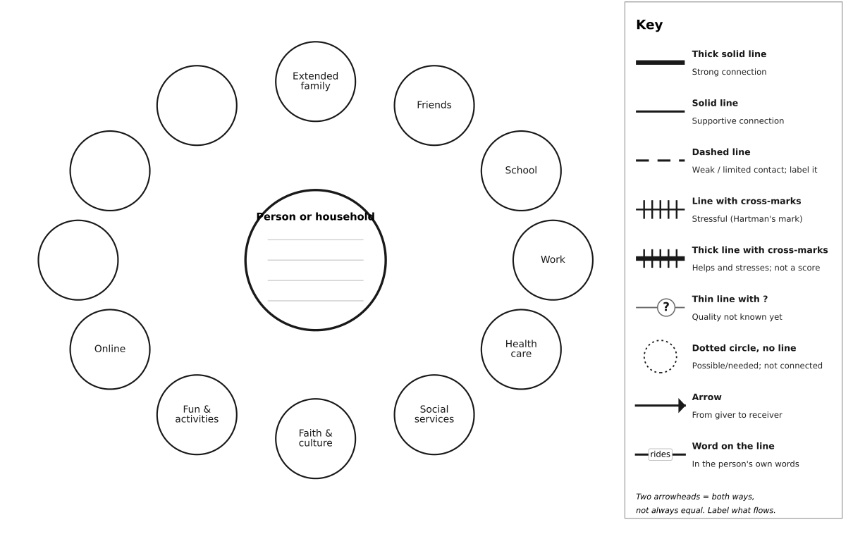
This page prints as a ready-to-use ecomap. Type into the header above and the worksheet on the next page. To drag circles and lines on screen, use the PowerPoint version.

Connection worksheet
Fill this in first, then draw each line on the map. Write what the person said, not what you guess.
# | Who or what (outside circle) | Attached to (household or which person) | What the person said (their words) | Line from the key | Arrow: who gives what to whom | Word for the line | Still unknown?
1
2
3
4
5
6
7
8
9
10

The Castleport Ecomap Key
